**Module 6: Lab Activity – Creating and Using Python Functions**

**Deliverables:**

Python programs for problems 1 though 6 below. Use the standard naming conventions.

**All submitted code must include comments:**

# Your Name

# The Date

# The Problem Number and Description

# Any other information throughout your code that is helpful

Python functions are a named sequence of statements that belong together.

All defined functions use the same setup. They consist of compound statements that include a header line and a body as shown below.

def functionName(parameter1, parameter2, etc)

# All statements that are part of this function are

# included here with indention

print(parameter1 + parameter2) # Sample statement

All defined functions must first be defined. To use them, they must be called, passing any needed parameters.

functionName(10, 20) # Sample function call using above example

**Problem 1:** Write a function areaOfCircle(r) which returns the area of a circle of radius r. Make sure you use the math module in your solution.

**Problem 2:** Write a Python function to check whether a number is in a given range. Use range(1,10). Print whether the number is in or not in the range.

**Problem 3:** Write a Python function to multiply all the numbers in a list. Use list [5, 2, 7, -1].

**Problem 4:** Write a Python function that takes a list of numbers and returns a new list with unique elements of the first list. Use list [1, 3, 3, 3, 6, 2, 3, 5]. Use the append function.

**Problem 5:** Use the following chunk of code as a base to produce the image shown below.

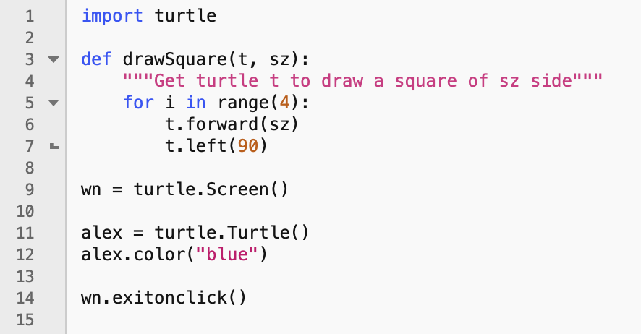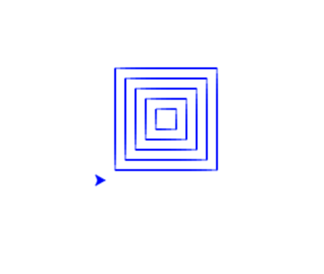

**Problem 6:** Use the polygon program from the last module and convert it to a function. Call the function in a way to create a pattern similar to below.

